EWB PDF Report – Team 2

# Peer Assessment 1

# Real-world problem and proposed solution

[Principal: I.E]

The quality of roads is very important to an economically developing area, as infrastructure facilitates the efficient transport of both people and goods. Problems arise, then, when the quality and general state of infrastructure falls, and damage from the elements is left to accrue over time due to lack of maintenance. This is an issue that Maker’s Valley and the entire city of Johannesburg faces with its roads currently.

* Potholes are a regular sight in many roads and can cause damage to vehicles and danger to drivers. With potholes, even a regular commute can become extremely hazardous, especially if at night.
* According to Discovery Insure, one of the founders of Johannesburg’s Pothole Patrol, potholes caused over R650 million (~£28.5 million GBP) in vehicle damages in 2021 alone[1]. Vehicle repairs are costly for drivers and have a social impact of reducing standard of living. Additional expenses mean less money to spend.
* Additionally, increased vehicle damage increases costs for insurance companies and makes investment in the areas with low quality infrastructure much less attractive, slowing down economic development dramatically.
* Vehicles then must drive slower to avoid this damage over unsafe streets which reduces the efficiency of the vehicle, thus leading to more fuel consumption and pollution. Some potholes can make certain roads untraversable.
* An example of the impact of untraversable roads, while not being a pothole, is the big hole on Derby Road in Maker’s Valley, which is the result of pipework underneath the road not being repaired. This road is practically untraversable in one direction due to the hole. This significantly reduces the throughput of the road, slows down movement, and can also lead to drivers taking longer, alternative routes. Potholes of significant sizes can also cause these sorts of blockades on roads.
* The Pothole Patrol founded by City of Johannesburg, Avis, and Discovery Insure have been working to fill these potholes across the entirety of Johannesburg, filling in over 50,000 since 2021[1].
* However, the sheer number (and size) of potholes still left in Maker’s Valley is evidence that there is still a problem. The people of Maker’s Valley previously went out to try and fix these potholes in their local community themselves but were prevented from doing so by the city, even on minor damages to the road. They did not have training and the people who filled in the potholes would be liable for any damages caused by incorrect repair on the road.

Each member of our team has conducted research on potholes in Maker’s Valley, how to repair potholes, or the effects of potholes on a community and an economy. Our solution is a result of every member’s voice being heard and multiple discussions on how best we can help the people of Maker’s Valley fix their roads. As a result, many unique perspectives and arguments were raised. The overall buildup to forming our solution has been summarised below.

* A solution including specialist equipment and personnel could repair many of the roads in Maker’s Valley to a very high quality, however the main problem with this solution is the procurement of funding for these expensive specialised methods, especially over an extended period.
* Looking at solutions to similar problems elsewhere, the Devon County Council in England trained volunteers in 2016 to help fill minor potholes due to budget cuts reducing the council's ability to fill in minor potholes themselves[2]. After a trial in 5 parishes, these ‘Road Wardens’ filled in over 200 potholes with a roadwork material from instarmac, and the initiative is still running as of the writing of this document.
* Larger potholes however require specialist equipment to fill in safely and permanently, and it would be unfeasible to train people up to the level of professional road workers due to costs.

Inspired by the volunteering idea, our solution seeks to partner with the Pothole Patrol to bring in trained professional staff from the patrol to train volunteers from Maker’s Valley in how to correctly fill in the smaller potholes and maintain the streets of their community.

* As described in the problem statement earlier, the community is certainly willing to fix these potholes themselves, meaning the gathering of volunteers will not be difficult.
* This will lift pressure off the Pothole Patrol and allow them to focus on larger, more demanding potholes that require specialist equipment and cannot be filled by our volunteers.
* We seek to train the volunteers from Maker’s Valley in how to use a typical cold asphalt mix to fill in smaller potholes, instead of the specific instarmac used by the devon council, though similar results should still be expected.
* Over time we will see the streets of Maker’s Valley become safer, less damaging places to drive. This will remove a big roadblock on the development of the minibus taxi service and allow greater transportation and connectivity within the community.

An abstracted, gamified representation of our solution will be developed to show how we can overtime teach volunteers from Maker’s Valley to help repair their roads and create a safer space to travel.

# Gamification of the real-world problem (use cases)

**[Principal: P.R.]**

**[Support: N.W, C.S.M.]**

## Use case descriptions

Below are a set of descriptions of our **most significant use cases** for the game:

### Start Game Setup & Player Introduction

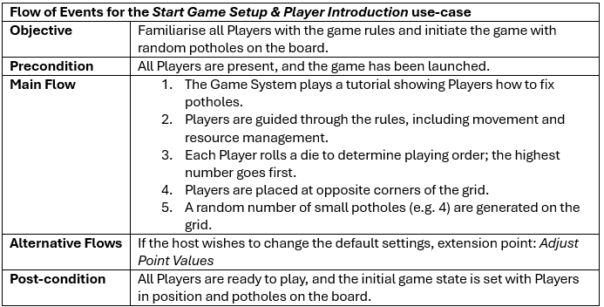

### Adjust Point Values

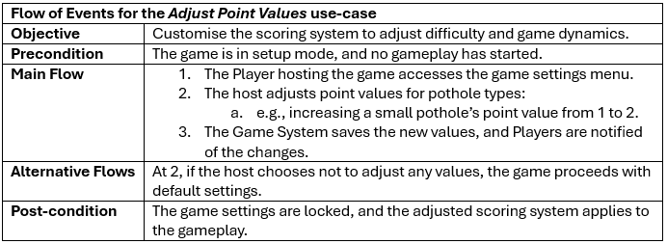

### Resolve End of Round

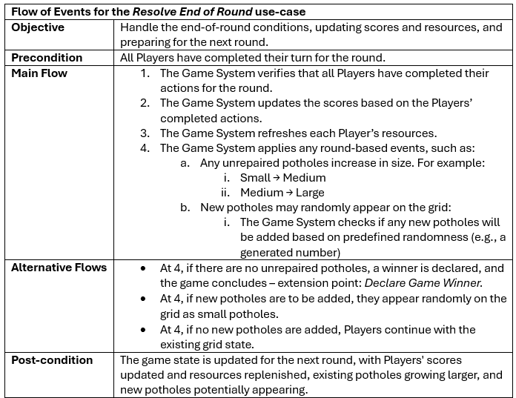

### Declare Game Winner

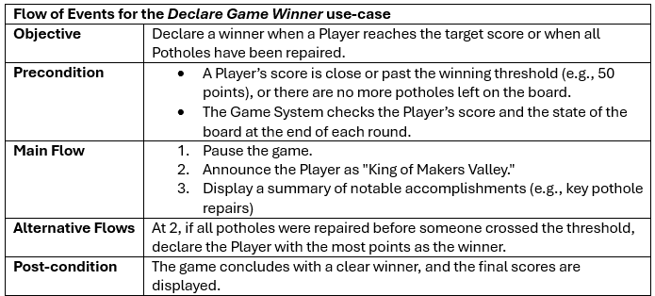

### Allocate Starting Resources

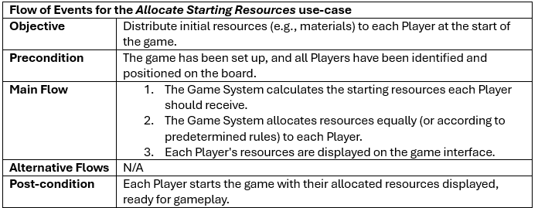

### Track Player Score

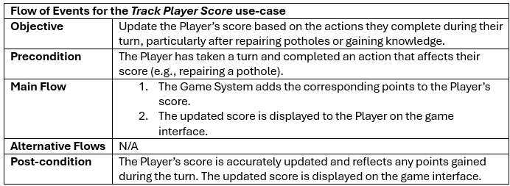

### Move Player

### Encounter Pothole

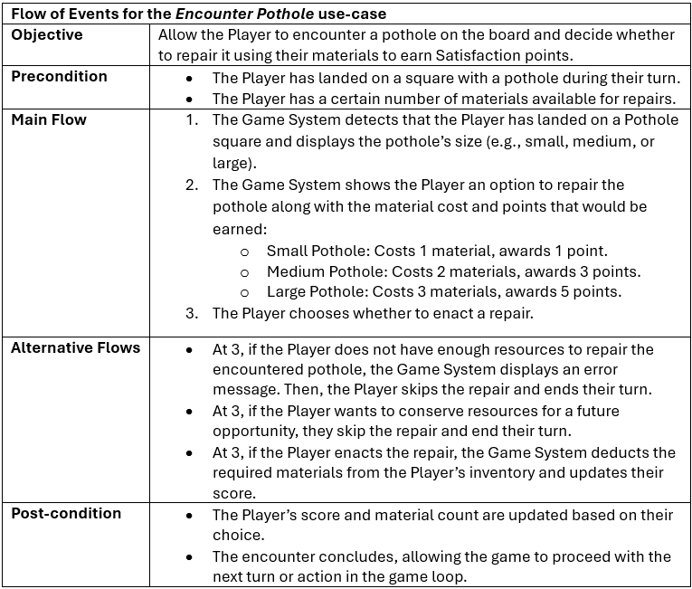

### Encounter Knowledge

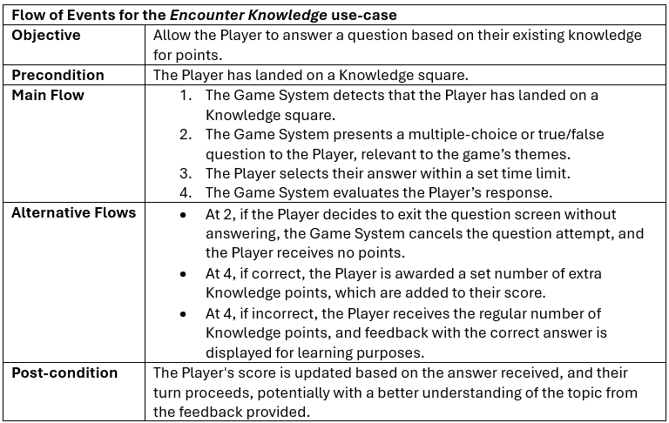

### Encounter Resource

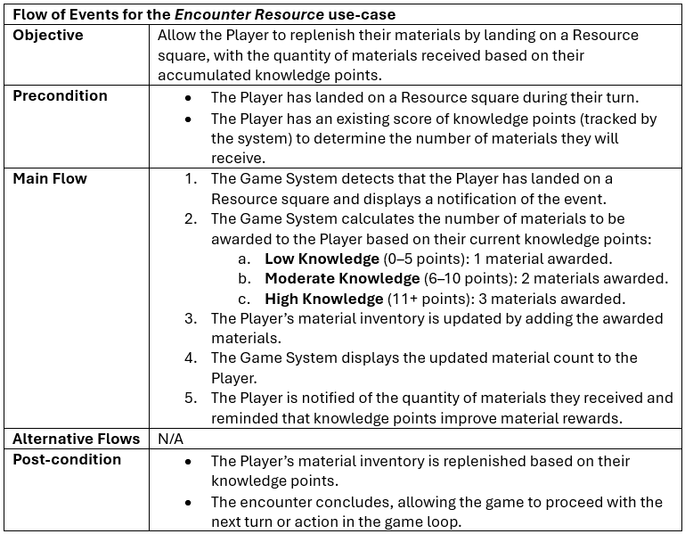

## UML use case diagram

Below is our diagram showing the **most significant use cases** that we propose for our game, including the relationships between them:

# System Analysis for the Game

## Initial UML Class Diagram

## Use case realisations/UML sequence diagrams

## Draft game layout

Example 15x15 board (red represents Pothole, blue represents Knowledge, green represents Spawn). As players are free to move in the 4 cardinal directions, there is no square flow:



**Square 3F**

**Empty Square**

A sign of good work. A pothole or knowledge square can develop on this square.

You can view your resources here or plan your next move.

**Square 15A**

**Spawn Square**

Player: X

Free Parking. You’re safe here.

You can view the opening tutorial from this square.

**Square 4C**

**Knowledge Square**

Q: X?

1. A

2. B

3. C

4. D

**Square 1D**

**Small/Medium/Large Pothole**

Age: x Days

Knowledge to Repair: y

Cost to Repair: z Resource

A damaged part of road which could cause issues for road users.

# References (Appendix)

[1] - According to Discovery Insure, over R650 million in vehicle damage caused by potholes in South Africa in 2021 alone. Since the Pothole Patrol initiative was launched over 50,000 potholes have been repaired in Johannesburg. - <https://www.discovery.co.za/corporate/good-driving-pothole-patrol-driving-change>

[2] - Devon County Council’s initiative to have volunteer Road Wardens fix minor potholes - <https://www.transport-network.co.uk/Council-uses-volunteers-to-fill-in-potholes-citing-cuts/13368>

# Team Minutes (Appendix)